CSIR-CMERI, Durgapur, unveils the COVID Protection System (COPS) for Workplace
CSIR-CMERI, Durgapur, unveiled the COVID Protection System (COPS) for Workplace as a game-changer in the current Pandemic Scenario. Prof. (Dr.) Harish Hirani, Director, CSIR-CMERI, Durgapur, while unveiling the COPS for Workplace conglomeration of technology, stated that, “Apart from the Healthcare Workers, the frontline Security Guards of any organisation are also very vulnerable to COVID through infected individuals and contaminated objects. CSIR-CMERI, Durgapur, in the near future will be developing a Digital Entry Management Systems whereby workflow would be automated and would be based upon Artificial Intelligence and Internet of Things. The COPS for Workplace includes contactless Solar Based Intelligent Mask Automated Dispensing Unit cum Thermal Scanner (IntelliMAST), Touchless Faucet (TouF) and 360° Car Flusher are now available for Technology Transfers and Product Orders.”

Dr.Hirani further stated that, “CSIR-CMERI, Durgapur, aims to support and align the Start-Ups and Entrepreneurs while developing its technologies to give boost to their aspirations and give them a platform to showcase their Innovative potential. CSIR-CMERI is also focused upon developing products Made in India, which will consequently boost the Atma-Nirbhar Bharat flagship initiative of the Government of India”.

The COPS is a conglomeration of the following technologies:
- Solar Based Intelligent Mask Automated Dispensing Unit cum Thermal Scanner (IntelliMAST)-The Solar Based IntelliMAST is an Intelligent surveillance kiosk which identifies the body temperature and whether an individual is wearing Face Mask or not through customised Software solutions. The information about an employee not wearing a Face Mask is provided to the Administration for Cashless delivery of the Mask and later deduction of the price from the Salary. In this regard the system harnesses Internet-of-Things in a seamless manner. The in-built Thermal Scanner detects probable rise in Body Temperature through forehead scanning and audio visual alert the Security Guards. The IntelliMAST will help ensure safety of supervising staff and implementation of precautionary measure in any large organization. The IntelliMAST will also facilitate Identity Card based Mask Dispensing & Attendance System. Facial Recognition based &ID Card based Attendance System will be incorporated into the system in the near future and therefore may act as a comprehensive solution for Office & Industrial Complexes as well as School & College campuses. This system uses Artificial Intelligence and Information Technology to give real-time results and can be synchronised with the Human Resource Data of any organisation for any real-time data response and dissemination of information. The IntelliMAST system is backed up by Solar Power for uninterrupted Power Supply during blackouts. The power supply requirement of the IntelliMAST is 40-50 Watts sourced through a Hybrid combination of Solar Power & Electricity.

- Touchless Faucet (TouF)-The Touchless Faucet (TouF) is being launched for households and Office Spaces. The system dispenses Liquid Soap and Water from the same Faucet with a time-gap of 30 seconds, which is as per the latest Government guidelines. The Faucet can be very easily mounted on top of any Wash-Basin and will be available in Plug and Play mode for very easy installation. This System dispenses Water 30 seconds after dispensing Soap in a Touch-free Mechanism as per Local Government guidelines and can be very easily mounted on top of household wash basins. This domestic variant of the Dispensing system will help in arresting the contamination and help in further containing the spread of infection among the family members, for any asymptomatic individual. The technology has a power supply requirement of only 10 Watts.

- 360° Car Flusher: The CSIR-CMERI developed 360° Car Flusher is a Sodium Hypochlorite Water Screen which uses specialised Nozzle Design to ensure that the Sanitizer Diffused Water is evenly spread over and under the Car Body/Wheels with adequate Water Force and coverage. The Architecture of the 360° Car Flusher is based upon a Water Channel Frame with appropriate number of specialised Nozzles which can be customised and modified as per the specific requirements of any particular organisation. The Water Channel Frame and Nozzle Design of the Flusher have been optimised to ensure Water Efficiency and reduce Water Wastage. It requires 750 watts of power required to run a pump.
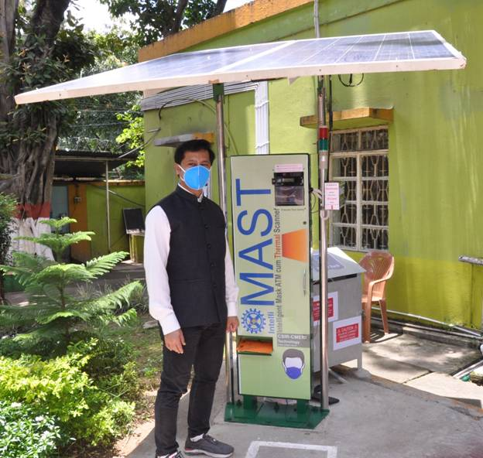

Source
Press Information Bureau, 19 July 2020

